Community Based Mathematics Project
of Philadelphia

CBMP

Data Deals

Sample Solutions

Strategy #1: Making a Table

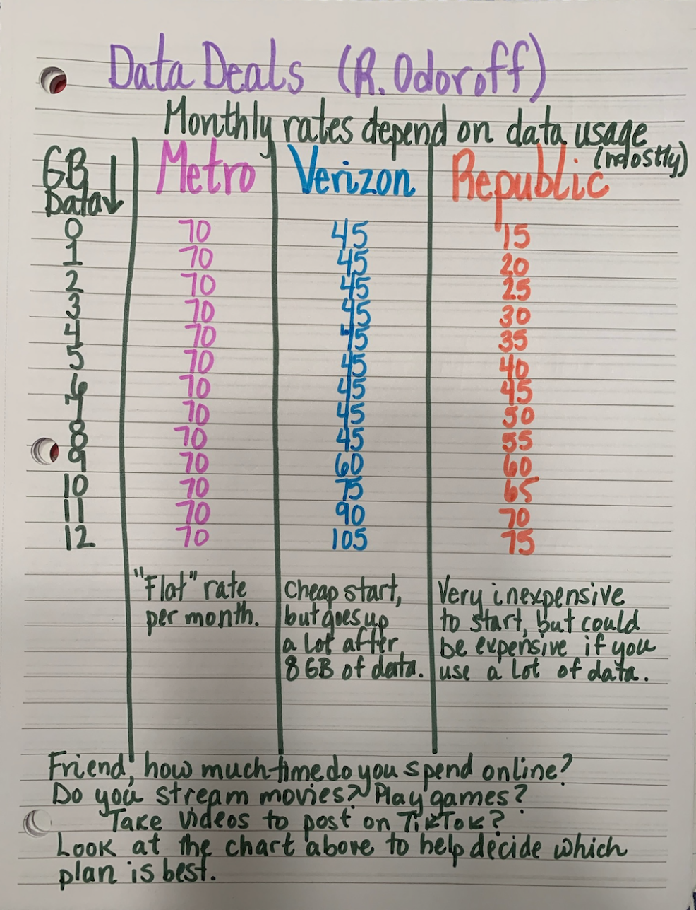
Best plan for 0-6 GB is Republic.
Best plan for 6-9 GB is Verizon.
Best plan for 9-11 GB is Republic.
Best plan for 11 or more GB is Metro.
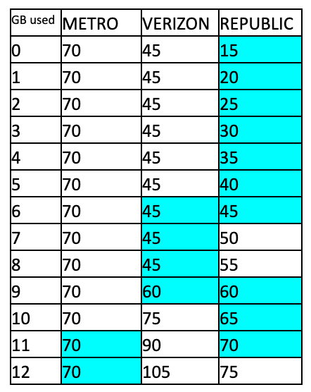
Strategy #2: Using equations to make a table

x = number of GB

Metro: y = 70x

Verizon: when x ≤ 8, y = 45
when x > 8, y= 15 (x-8) + 45

Republic: y= 5x + 15

Strategy #3: Using a system of equations

Metro: y=70
Verizon: y=45 when x ≤ 8; y=15(x-8) + 45 when x>8
Republic: y=5x+15

Metro & Verizon
70 = 15(x-8) +45
70 = 15x - 120 + 45
70 = 15x -75
145 = 15x
x = 9 ⅔ GB used
When 9 ⅔ GB’s are used Metro and Verizon cost the same amount.

Metro & Republic
70 = 5x + 15
55 = 5x
x = 11 GB used
When 11 GB are used Metro and Republic cost the same amount.

Verizon & Republic
15(x-8) + 45 = 5x + 15 5x + 15 = 45
15x - 120 + 45 = 5x + 15 5x = 30
15x - 75 = 5x + 15 x = 6 GB
10x = 90
x = 9 GB
When 9 GB or 6GB are used Verizon and Republic cost the same amount.

If the friend uses 6 GB or less, Republic would be the cheapest. Between 6 and 9 GB, Verizon is cheapest. If she uses between 9 and 11 GB, Republic would be the cheapest and if she uses 11 or more GB it would be cheapest to use the Metro plan.

Strategy #4: Using a graph
