Community Based Mathematics Project
of Philadelphia
CBMP

What are the Chances? Playing the Lottery
In Pick 3, the player chooses three numbers from 0 – 9. You can choose the same number more than once. On this ticket, the person chose the numbers “123.”
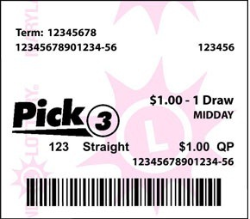

Each day, three numbered balls are randomly chosen.


If your numbers match those on the numbered balls, you win!
You can choose to bet in different ways. The amount you win is determined by the type of bet.
Bet Types | If the winning balls are 123, you would win if you got…
STRAIGHT: Choose three digits. If all three are drawn in the same order, you win. | 123 exactly
BOXED: Choose three digits. If all three are drawn in any order, you win. | 231 or any other order of the numbers 1, 2, and 3.
FRONT PAIR: Choose two digits in the front. If both are drawn in the same order, you win. | 21* or 12* (The * means that the last ball doesn’t count.)
BACK PAIR: Choose two digits in the back. If both are drawn in the same order, you win. | *32 or *23 (The * means that the first ball doesn’t count.)
Exploration

How many possible combinations of 3 digits are there? How do you know? This is called determining the sample space.

If you are playing front pair, only the first two balls matter, and they must be in the same order. Choose the two numbers that you want to try:

_________ ________ * .
What is your chance of winning? Show your work.

If someone chose the numbers 33*, would they have a better, worse, or the same chance of winning compared to your choices? How do you know?

If you are playing straight, all three numbers count, and they must be in the same order. Choose the three numbers you want to try:

_________ ________ ________
What is your chance of winning? Show your work.

If someone chose the numbers 333, would they have a better, worse, or the same chance of winning compared to your choices? How do you know?

If you are playing boxed, all three numbers count and they can be in any order. However, you can only choose each number once.
Choose the three different numbers you want to try:

_________ ________ ________
What are your chances of winning when playing boxed?

If it were possible for someone to choose the numbers 333 when they played boxed, would they have the same, better, or worse chance of winning boxed compared to your choices? How do you know?

