Community Based Mathematics Project
of Philadelphia
CBMP

Example Shapes in Bridges

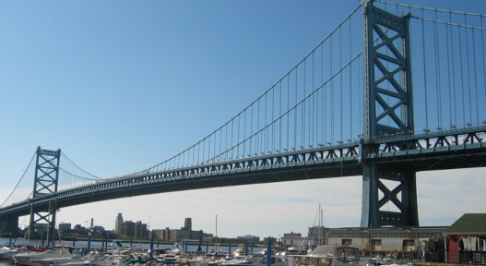
Right angles/perpendicular lines
Parallel lines/trapezoids

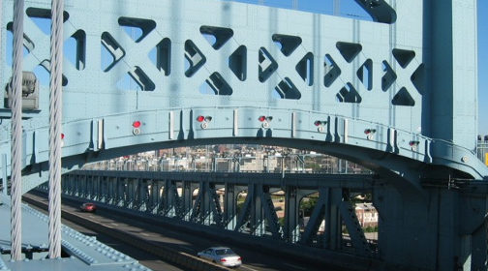
Squares with right triangles inside
Right isosceles triangles with 2 acute angles
Symmetry
Curves

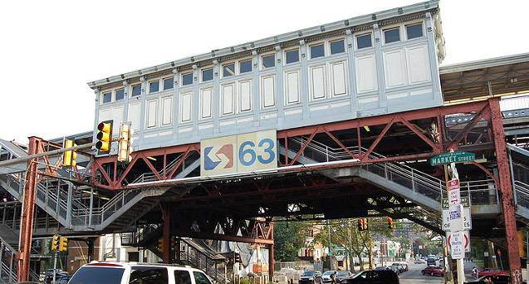
Right triangles with two acute angles
Triangles that meet at the same point
Parallel lines and perpendicular lines
Right and acute angles, but no obtuse angles

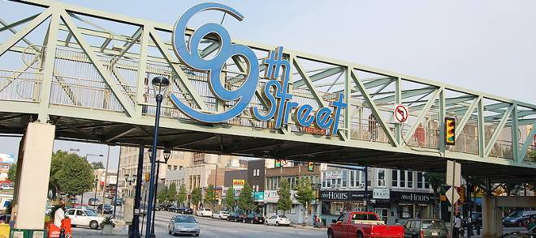
Right triangles with two acute angles
Triangles that meet at the same point
Parallel lines & perpendicular lines

