Community Based Mathematics Project
of Philadelphia
CBMP

Building Bridges: Triangles and Quadrilaterals

Do you recognize these structures?
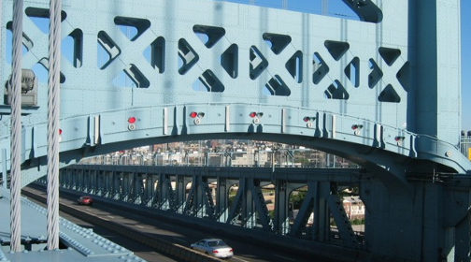
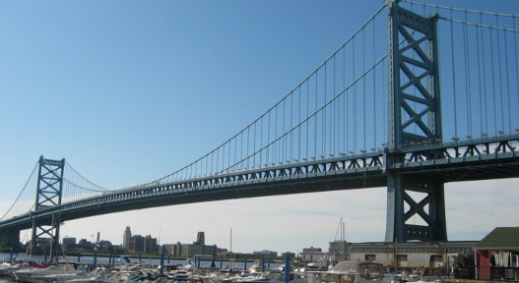

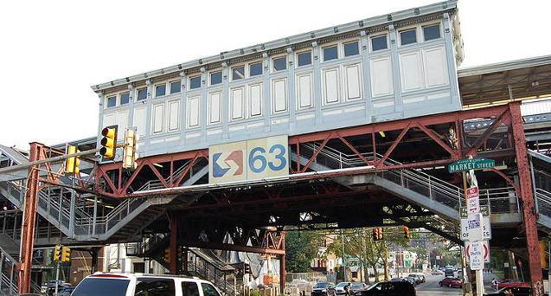
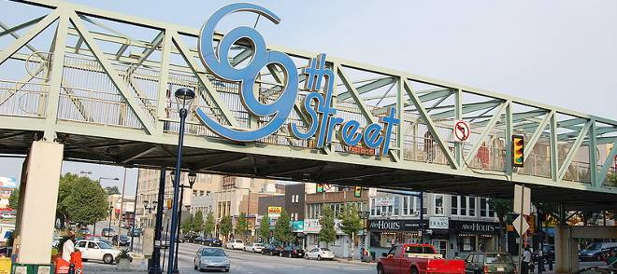

What shapes can you identify in the structures?

Exploration
Testing Shape Strength
Today we will be engineers and experiment with the strength of different shapes.
Decide which shape you will make: ______________________________
Cut straws to the lengths you need and connect the sides with either twist ties or paper clips..
To use twist ties, stick them into the ends.
To use paper clips, link the paper clips together first, then push them into the straws

Sketch a picture of your shape and name it as specifically as you can (e.g., isosceles right triangle). Try to gently push your shape. What happens? Explain.
Shape name:

What other shapes are you curious about? Try building them, then explain what happens when you push gently.
Shape name:

Shape name:

Shape name:

Shape name:

Use your hypotheses to try more shapes. Describe what happens when you push or pull gently on them.
Shape name:

Shape name:

Shape name:

Shape name:

