Community Based Mathematics Project
of Philadelphia
CBMP

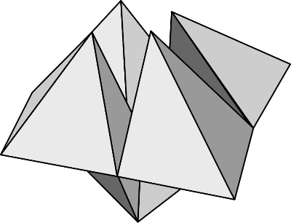
Fortune Tellers: Deriving Area Formulas

What are fortune tellers?
Fortune tellers are an origami shape made by folding a piece of paper following a set of specific steps. Some people write numbers, letters, or messages inside the folds, then bend the fortune tellers and open up a tab to reveal the “fortune.”
Facts:
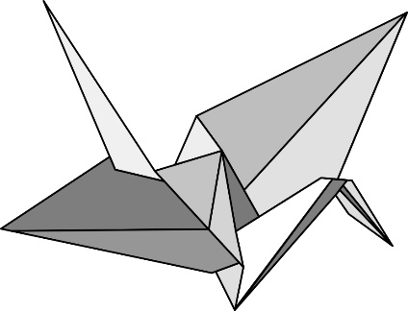
- Origami means “folding paper” in Japanese. This ancient art has been handed down from parents to children for 300 or 400 years.
- Origami patterns can be used to make flowers, fish, frogs, and many other shapes. The most popular is probably the crane.
- Traditional origami is always made with a square paper, with no cutting, gluing, or markings.

Making a Fortune Teller

Cut an 8 × 8 square from the rectangle on the back page. Put it grid-side-down on the table. Follow the first step to making a fortune teller, as shown:

Step 1    Fold the opposite corners together. | Shape:  Area:  Fraction of original area: | I found the area by…
Summarize the result of each step in the table below:
Step 2  Fold the opposite corners together, then open it. |  | Each triangle:  Shape:  Area:  Fraction of original area: | I found the area by…
Step 3  Fold one corner into the point where the diagonal lines intersect. |  | Each small triangle that is folded in to the center:  Shape:  Area:  Fraction of original area: | I found the area by…
Step 4  Repeat with the other corners. It should look like this. |  | The small square:  Area:  Fraction of original area: | I found the area by…
Step 5  Flip the paper over. |  | Each small square:  Area:  Fraction of original area: | I found the area by…
Step 6  Fold the first corner into the center. | The small triangle:  Area:  Fraction of original area: |  | I found the area by…

Making a Trapezoid

Fold the opposite corner so that the points meet in the middle. Then fold the figure in half:

This shape is a trapezoid because it is a quadrilateral with two parallel sides. A trapezoid has two bases and a height.
b₂
h
b₁

Draw the outline of your trapezoid here:

What are the dimensions of your trapezoid? b₁ = b₂ = h =

What is the area of your trapezoid?

How did you find the area? What other methods could you use to find the area?

Complete the Fortune Teller
Undo the last three folds that you used to make the parallelogram and trapezoid. Your paper should look like this again.

Keep following the directions to make the fortune teller.
Step 7 | Fold in the other 2 corners. It should look like this. | The square:  Area:  Fraction of original area: | I found the area by…
Step 8 | Fold it in half vertically, then open it. Repeat by folding it horizontally. | The rectangle:  Area:  Fraction of original area: | I found the area by…
Step 9 | Open each of the squares on the outside. Put your thumb and three fingers into the openings. | Each square on the outside:  Area:  Fraction of original area: | I found the area by…

