Community Based Mathematics Project
of Philadelphia
CBMP

Comparing High Schools: By the Numbers
Dot plots

A dot plot starts with a number line. Each data point is represented by an X or dot above its place on the number line. If several values are the same, add an X or dot for each one.
Create a dot plot for the citywide school attendance data.

What do you notice about the citywide attendance data when they’re shown on the dot plot?
More of the data points are clustered around 91. The points are closer together on the right and farther apart on the left. The lowest school has an 82% attendance rate and the highest has a 95% attendance rate. Two of them have a 91% attendance rate.

What information does a dot plot show you that the mean or median does not?
How spread out the data is. Whether or not it’s symmetric. How many data points there are.

The Five Number Summary
Instead of giving just one number, box plots give a five number summary for a data set. Find all five values for the citywide attendance data.:
Minimum (lowest value) 82
Lower Quartile (the median of the lower half) 87
Median (value with the same number of data points above and below) 90.5
Upper Quartile (the median of the upper half) 91.5
Maximum (highest value) 95
The median is above 50% of the values and below 50% of the values. It is called the 50th percentile or 50%ile.
The lower quartile is above 25% (one quarter) of the values and below 75% (three-quarters) of the values. It is also called the 25th percentile or 25%ile.
The upper quartile is above 75% of the values and below 25% of the values. It is also called the 75th percentile or 75%ile.

Box Plots
To create a box plot, draw a line for each number in the five number summary. Connect the middle three with a box, and the outer two with lines.
Create a box plot for the citywide attendance data.

The range is the distance from the lowest value to the highest value. The interquartile range (IRQ) is the distance between the lower quartile and upper quartile. Find the range and IRQ for citywide attendance.
Range 13 IRQ 4.5

Exploration
Comparing Dot plots
How does the attendance data for citywide schools compare to neighborhood, special admissions, and charter schools?
To compare them, create a dot plot that shows all four types of schools. Use Xs or dots with different colors and remember to create a key.
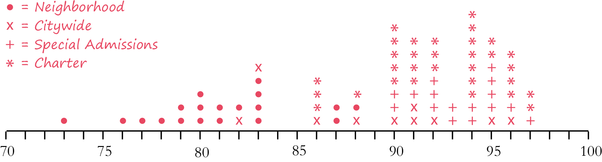

Comparing Box Plots
Create a box plot that shows all four types of schools. Put each school type in its own row and put a label next to each one.
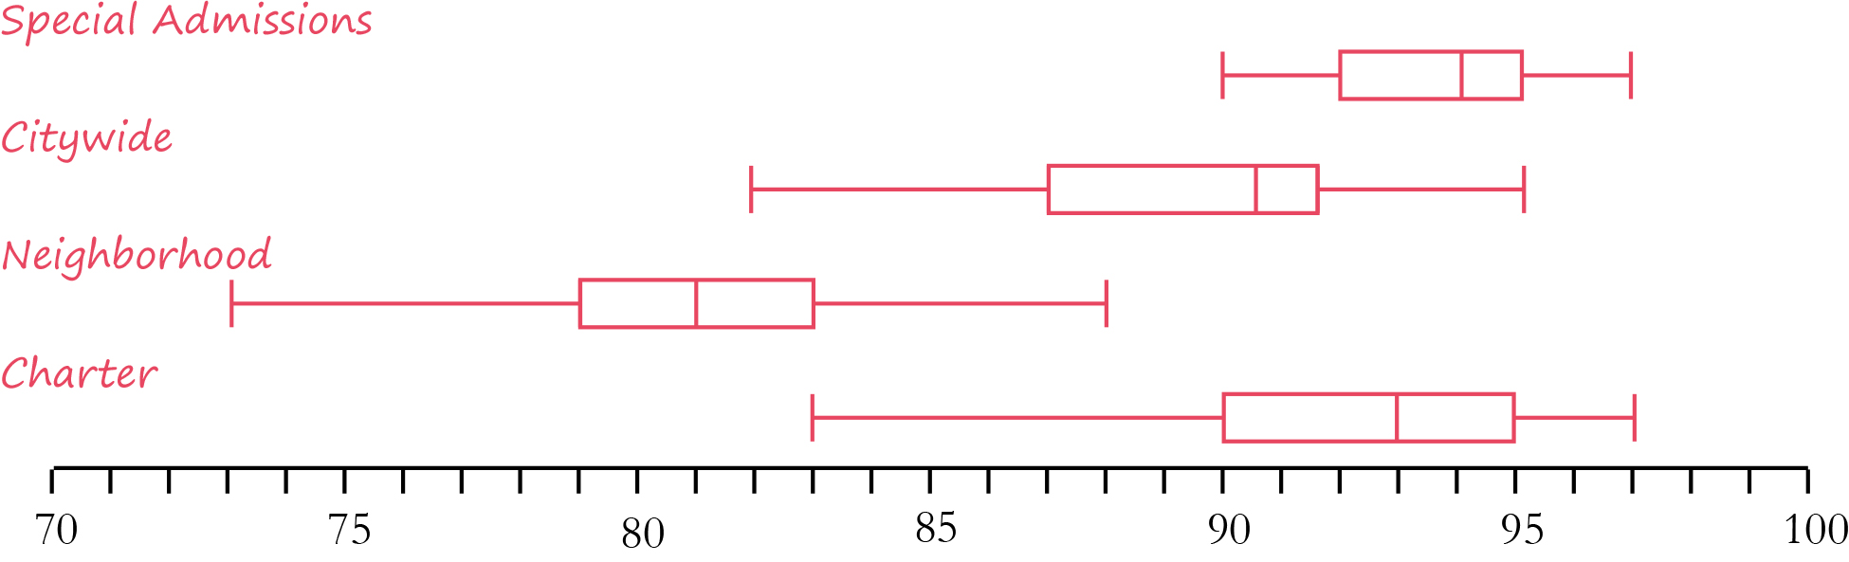

What is the range and IRQ for each school type?
Neighborhood: Range 15 IRQ 4
Citywide: Range 13 IRQ 4.5
Special Admissions: Range 7 IRQ 3
Charter: Range 14 IRQ 5

What do you notice about the attendance rates at the four different types of high schools? Think about how each school type compares to each other school type. For example, is the median for one school close to the minimum, LQ, median, UQ, or maximum for another school?
Use information from the five number summary, the range, and the IRQ to compare the data.
The upper quartile for neighborhood schools is close to the minimum for the citywide and charter schools, so 75% of neighborhood schools have attendance rates below the rates of any other school type.
The maximum for neighborhood schools is close to the lower quartile for citywide and charter schools, so the top 25% of neighborhood schools are like the bottom 25% of citywide and charter schools. The neighborhood schools have no overlap with special admissions schools.
The overall distribution of the charter schools is like a combination of the overall distribution for citywide and charter schools combined. For charter schools, the minimum is close to the minimum for citywide schools, the LQ is close to the median for citywide schools and the minimum for special admissions schools, the UQ is close to the maximum for citywide schools and the UQ for special admissions schools, and the maximum is close to the maximum for special admissions schools.
Neighborhood schools have the greatest range, but charter schools have the greatest IRQ. This means that neighborhood schools have the greatest variation overall, but charter schools have more variation in their middle 50%.
Special admissions schools have the smallest range and IRQ, so they do not have a lot of variation.
The attendance rates for charter schools and citywide schools are skewed to the left. The median, UQ, and maximum are very close to each other so there is not a lot of variation in the upper half, but the minimum and LQ are farther apart so the lower half has more variation.
The attendance rates for neighborhood schools and special admissions schools are symmetric. The medians are about the same distances from both quartiles and about the same distances from both extremes.

