Community Based Mathematics Project
of Philadelphia
CBMP

Comparing High Schools: By the Numbers

Dot plots
A dot plot starts with a number line. Each data point is represented by an X or dot above its place on the number line. If several values are the same, add an X or dot for each one.
Create a dot plot for the citywide school attendance data.

What do you notice about the citywide attendance data when they’re shown on the dot plot?

What information does a dot plot show you that the mean or median does not?

The Five Number Summary
Instead of giving just one number, box plots give a five number summary for a data set. Find all five values for the citywide attendance data.:
Minimum (lowest value)
Lower Quartile (the median of the lower half)
Median (value with the same number of data points above and below)
Upper Quartile (the median of the upper half)
Maximum (highest value)
The median is above 50% of the values and below 50% of the values. It is called the 50th percentile or 50%ile.
The lower quartile is above 25% (one quarter) of the values and below 75% (three-quarters) of the values. It is also called the 25th percentile or 25%ile.
The upper quartile is above 75% of the values and below 25% of the values. It is also called the 75th percentile or 75%ile.

Box Plots
To create a box plot, draw a line for each number in the five number summary. Connect the middle three with a box, and the outer two with lines.
Create a box plot for the citywide attendance data.

The range is the distance from the lowest value to the highest value. The interquartile range (IRQ) is the distance between the lower quartile and upper quartile. Find the range and IRQ for citywide attendance.
Range IRQ
Comparing Dot plots
How does the attendance data for citywide schools compare to neighborhood, special admissions, and charter schools?
To compare them, create a dot plot that shows all four types of schools. Use Xs or dots with different colors and remember to create a key.

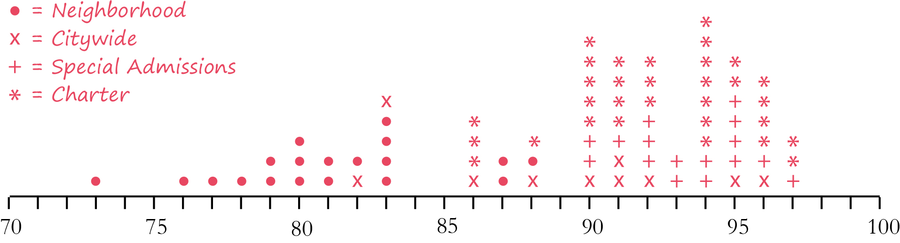

Comparing Box Plots
Create a box plot that shows all four types of schools. Put each school type in its own row and put a label next to each one.

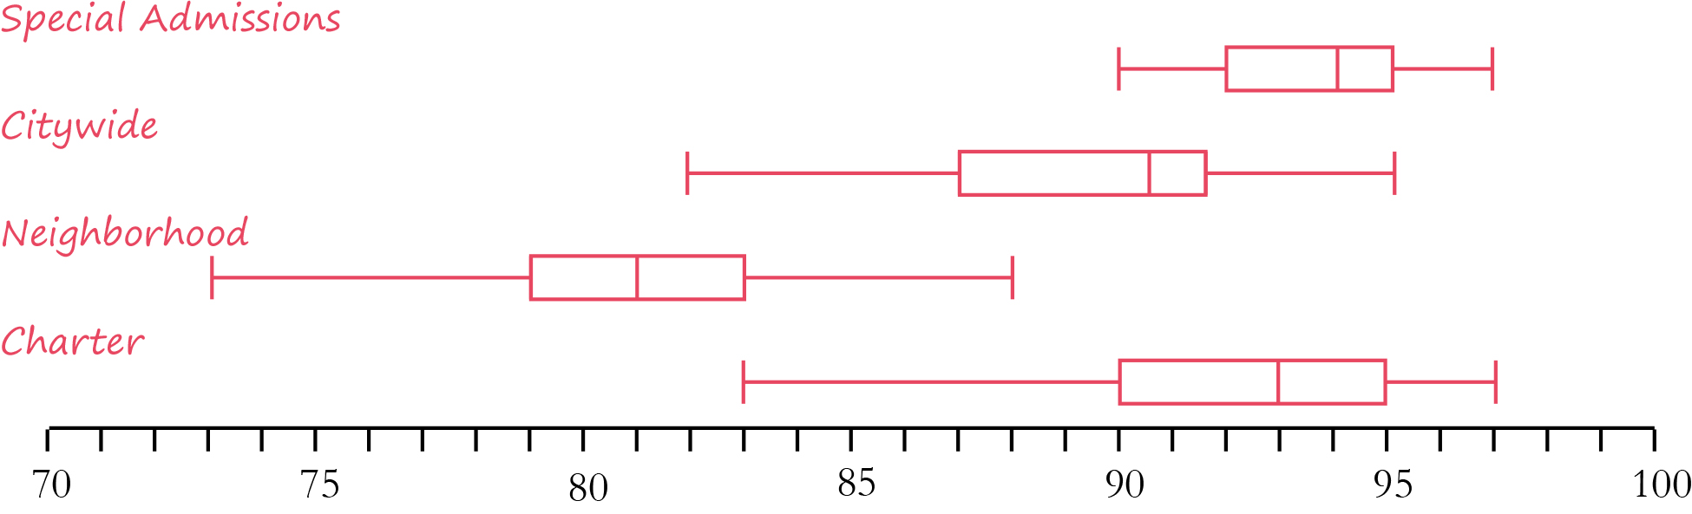

What is the range and IRQ for each school type?
Neighborhood: Range IRQ
Citywide: Range IRQ
Special Admissions: Range IRQ
Charter: Range IRQ
What do you notice about the attendance rates at the four different types of high schools?
Use information from the five number summary, the range, and the IRQ to compare the data.

Exploring Other Categories
Choose another category of the chart that you are interested in. (For example, percentage of low-income students, average SAT reading score, or college-going rate.
Use the space below to create a dot plot and a box plot comparing the four types of schools.
Dot plot

Box Plot

What is the range and IRQ for each school type?
Neighborhood: Range IRQ
Citywide: Range IRQ
Special Admissions: Range IRQ
Charter: Range IRQ
What do you notice about the category you chose for the four different types of high schools? Use information from the five number summary, the range, and the IRQ to compare the data.

